Team Iconic

Checkers Game

UI sketches (covering as many possible states)

In this document, we aim to provide basic UI sketches that we’ve made which will be helpful in understanding and further designing of possible states of checkers games.

1. The very first screen which would be displayed from where we would have to choose among the options: New Game, Statistics, Saved Games, Leaderboard, Contests, Exit along with some necessary options present in the menu bar as well.

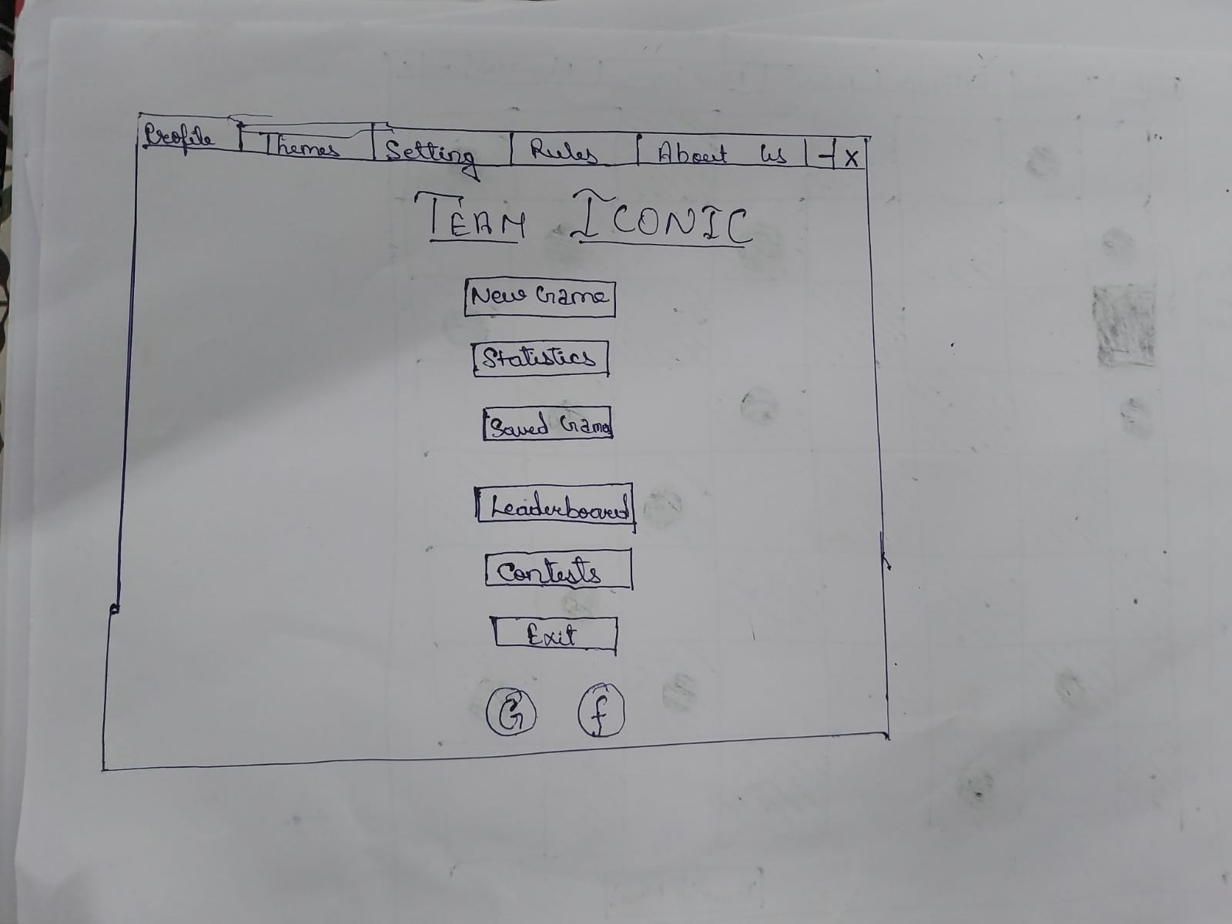

1. On choosing the option New Game, a new game screen will be visible with our board and the players would be now able to begin playing the game as shown below:

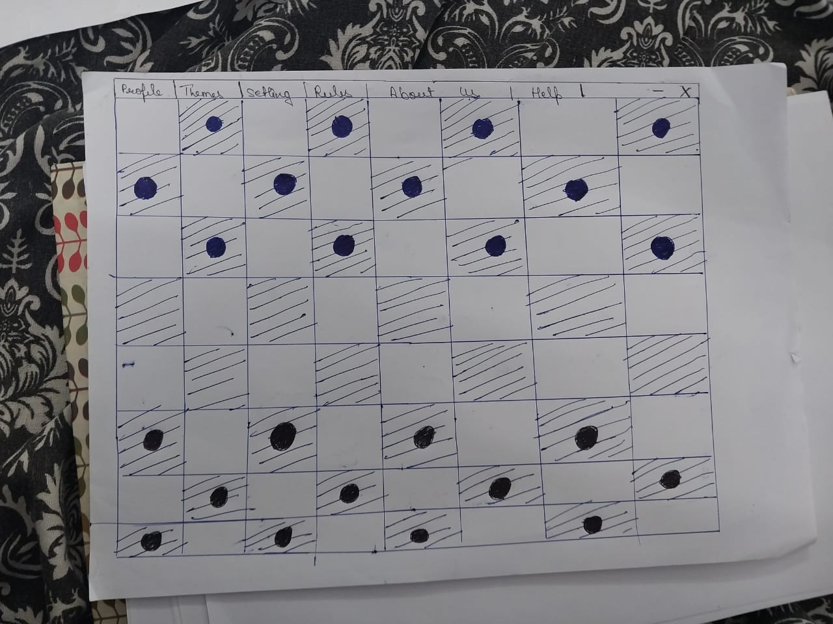

1. Now, this is how an invalid move pop-up will be shown on the game screen when the player tries to make an invalid move.

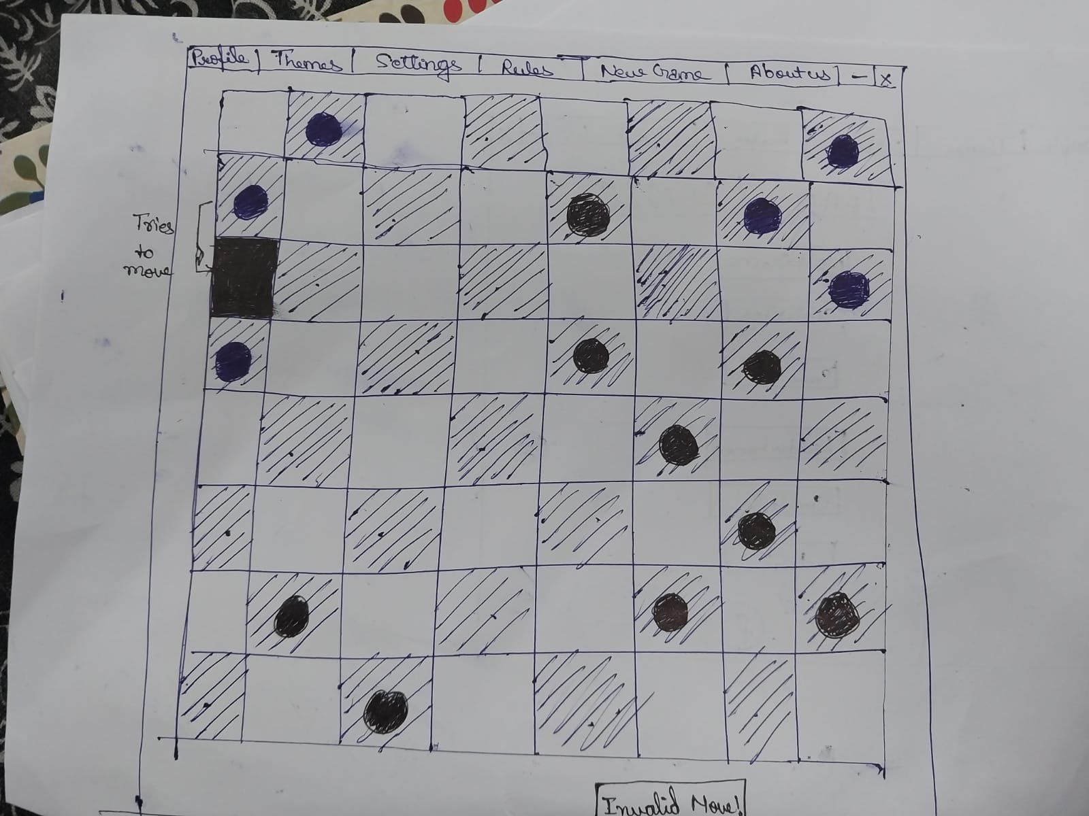

1. Here, we try to present the state when the player is provided with the options for valid moves that he/she may make which would be indicated on the board with a different shade or colour:

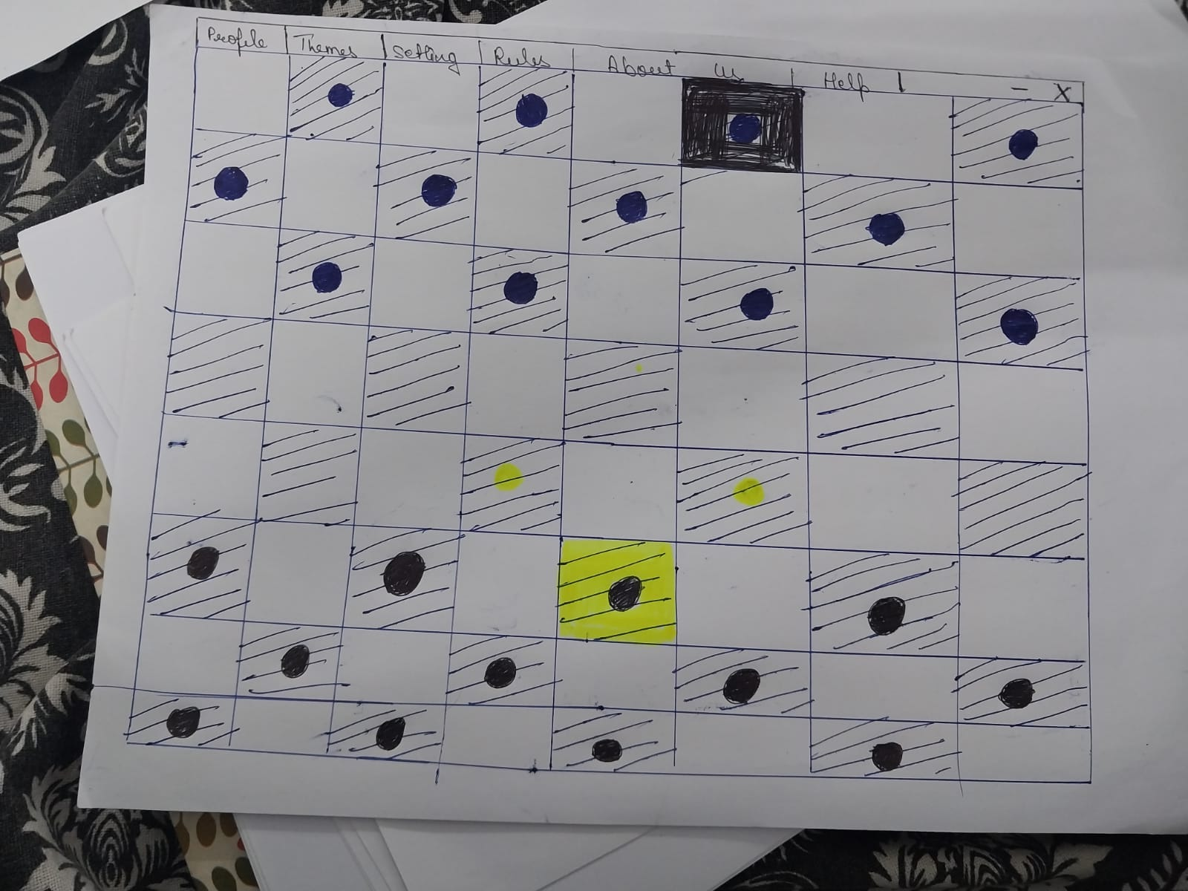

1. Now, going back on the first screen, we had a couple of other options like Statistics, Profile and Saved Games.

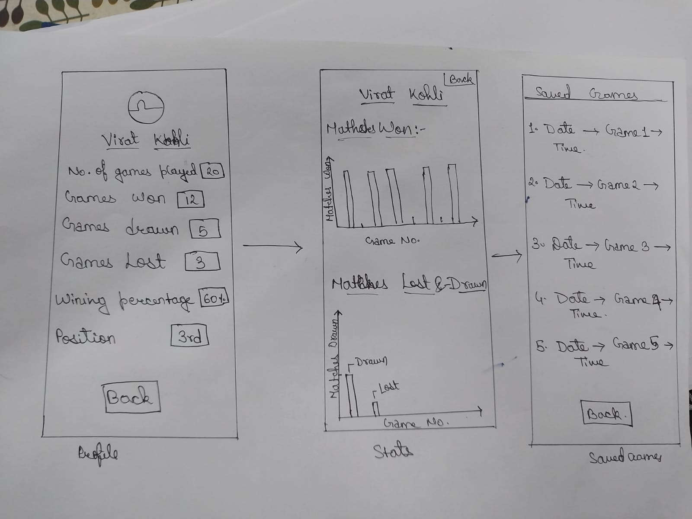

1. For leaderboard, contests and rules, we would have the following screen. Also, if at any point, the player wants to go through the rules of the game once again, then he/she may read the rules by clicking on the Rules option present in the menu bar and a screen as shown below will be visible to him/her.

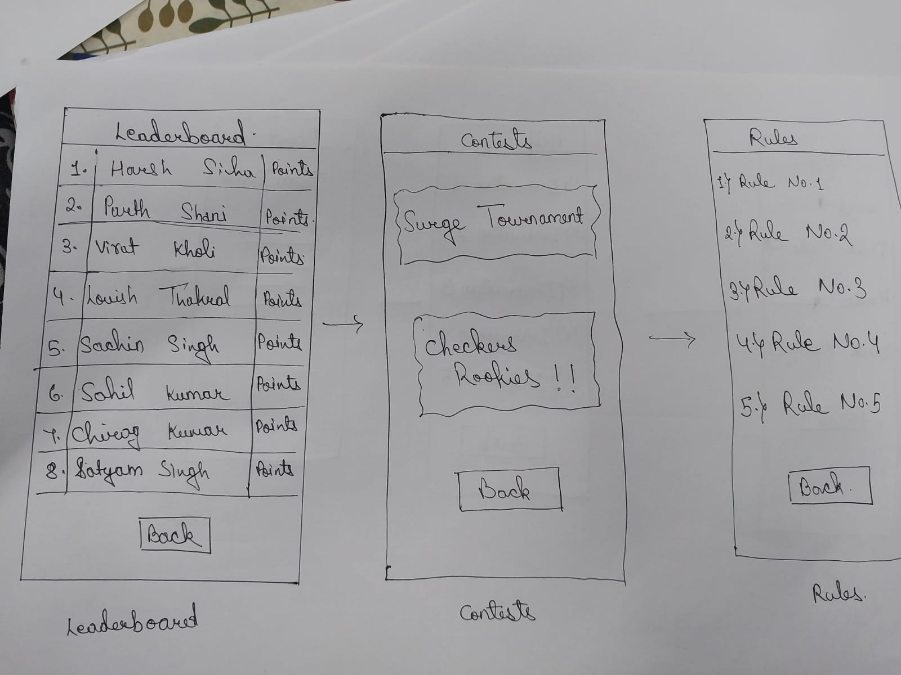

1. As shown in the sketches, we have a number of options in the menu bar like Settings (which would further include options like Sound, Dark mode which is usually very common these days, Music and then we give an option of Delete History to our players too), Help and About us so for that, this would be the screen displayed:

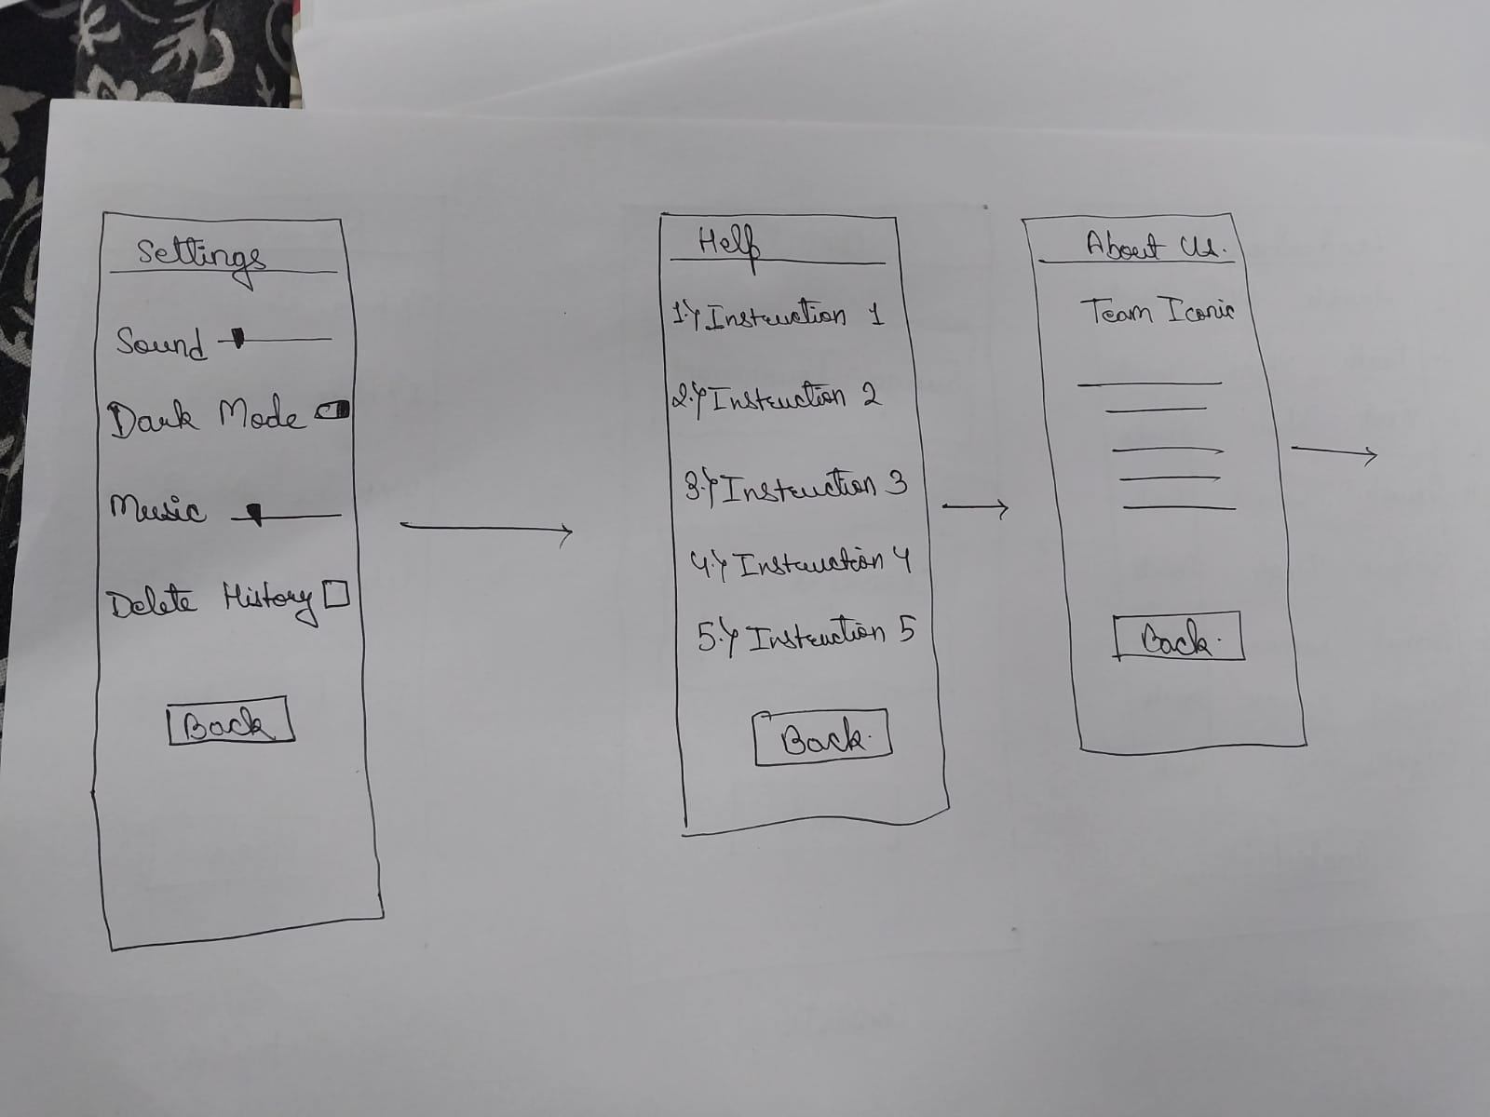

1. Here, we have some theme options (we have tried to keep it to basic themes only for now)

We can see the exit pop up here too, which asks the player to choose one of the three choices given: Save, Save and Exit, Exit as shown below:

